

GENERAL INFORMATION FOR PARTICIPANTS
Workshop
“Best-practices for the production and reporting of
SDG Indicator 14.4.1”
Rome, Italy, 21–24 November 2017
India Room
Starting Time: 9:00 am
Getting to the hotel from Fiumicino Airport
Direct train from LEONARDO EXPRESS STATION
Ticket EUR 14.00 - every day
Fiumicino Airport to Termini Train Station – every 30 minutes from 6:36 a.m. to 23:36 p.m
Termini Station to Fiumicino Airport – every 30 minutes from 5:52 a.m. to 22:52 p.m.
This train takes you from Fiumicino airport to Termini train and metro station. From Termini Station you will take the Metro Line B (direction to Laurentina) three stops to Circo Massimo (see map below).
There are two underground lines in Rome: Line A and Line B. The stops are marked by a red and white “M” sign. Termini Station is the only metro station where the two lines intersect. Tickets for public transportation should be purchased in advance and are available from underground stations, tobacco shops and newspaper kiosks. Tickets cost EUR 1,50 and may be used once for the metro and unlimited bus/tram travel within the ticket validation time of 100 minutes. Tickets are validated upon entering the bus/tram or at the point of entrance to the metro.
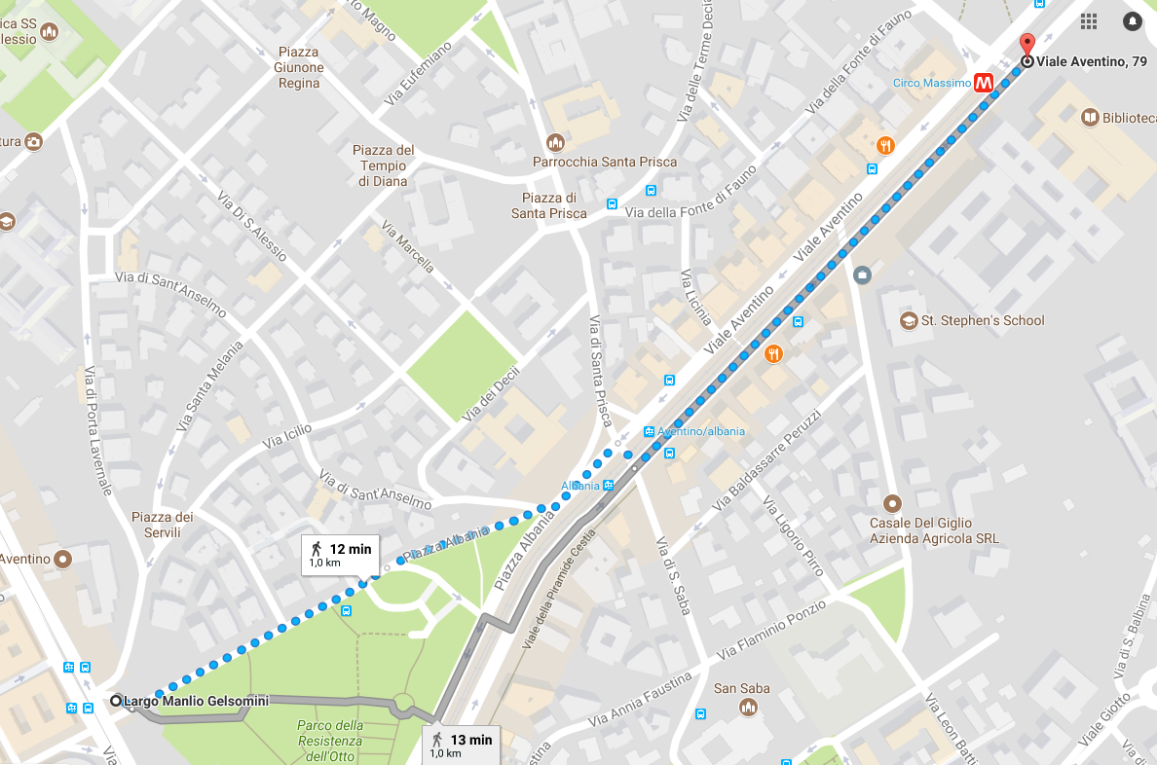
Santa Prisca Hotel
FAO Main Entrance
Circo Massimo Metro B Station
Taxis
Participants are advised to use only licensed taxis, which are usually white, with meters. Surcharge fares are applied for baggage, night runs, Sundays and holidays.
A taxi from Fiumicino airport to the hotel should cost exactly EUR 48.00 (this includes baggage and up to four passengers). If you are asked to pay more, please do not accept as most likely you are being ripped off. Please agree on this price before you get into the taxi.
FAO Headquarters location
The FAO Headquarters Complex is located on Viale delle Terme di Caracalla, in front of the Circo Massimo and close to the Colosseum. It can be reached by bus, tram, the metro B line (Circo Massimo stop) and by foot.
The workshop will take place in the Cuba Room (B224).
Access to FAO Headquarters
Access to the FAO Headquarters Complex is permitted only for persons who possess a valid Building Pass.
Participants must enter at the Main Entrance in Building A on the metro station side, and go to the Visitor Centre (security pavilion) to register and pick up their Building Pass. A valid identity document will need to be presented to registration officials in order to collect the Building Pass. Registration will be open from 8:00 a.m. to 5:00 p.m.
Strict security measures are observed at the FAO Headquarters Complex: metal detectors are in operation at the Building A entrance. Participants are requested to wear their Building Passes valid for the duration of the workshop at all times, so please try to arrive on time as it can be a time consuming operation due to the high level of meetings held each day.
Participants are reminded not to leave briefcases or any valuable items unattended in meeting rooms.
Medical Services at FAO Headquarters
The Medical Service provides emergency medical assistance in FAO to participants at meetings.
For medical emergencies within FAO Headquarters, dial 30 from all in-house telephones. For all other medical services, call ext. 53577 from in-house telephones.
Emergency Telephone Numbers in Rome
The following numbers may be useful in case of emergency outside FAO Headquarters:
- Medical Emergencies 118
- General Emergencies 113
- Fire 115
- Ambulance 118
- City Physician on call (Medico di Guardia) +39 06-58201030

Protecting Valuables
Participants are advised to carry their valuables in a safe place, especially on public transport. There might be pickpockets on the street, the underground and on buses and trams.
FAO Security
The FAO Security Office operates from 7:30 to 17:30 hours. To contact the Security Guards in Building A, dial ext. 53145 or +39 06 57053145 from outside FAO Headquarters.
The FAO Security Office:
- receives official telephone calls requiring follow-up action after normal working hours;
- assists in locating and notifying the Organization’s senior officials in an emergency;
- liaises with national security representatives regarding security arrangements for dignitaries;
- liaises with local authorities whenever outside emergency assistance is required (e.g. ambulance, medical, police);
- handles lost and found properties within FAO premises.
FAO Restaurants and Bars
Within the FAO buildings there are three coffee shops, a cafeteria and a restaurant. These facilities only accept Euro cash. No credit cards are accepted.
- Polish Bar: Coffee shop located on the ground floor of Building A. Serves coffee, tea, drinks, cakes and sandwiches all day, with cold meals for lunch. Hours from
7:30–17:00.
- Blue Bar: Coffee shop located on the 8th floor of Building C. They serve snacks and sandwiches all day, with cold meals for lunch. Hours from 7:30–13:00.
- Casa Bar: Building D ground floor. Salads and light meals, with cold and hot meals for lunch.
- Cafeteria: Self-service restaurant located on the 8th floor of Building B. They serve entrees, pasta, grilled meat and fish, salads, desserts and drinks. Hours 12–14:00.
- Restaurant: Located on the 8th floor of Building C. They offer a complete ‘menu of the day’ or ‘à la carte’ menu. Hours 12:00–14:00. Reservation required (extensions 54268 or 56823).
Vending machines with assorted refreshments are also located at various points throughout the premises, including the second floor of Building A where the meeting will be held and the ground floor of Building B.
Banks
You can carry out all banking operations within FAO, at the branches of Banca Intesa (ground floor, Building B) and Banca di Sondrio (ground floor, Building D). Opening hours are Monday-Friday, 8:40 to 16:30. Next to either bank you will find cash dispensers accepting international bank cards, at your disposal 24 hours.
Wi-Fi Coverage
FAO offers free Wi-Fi coverage in all meeting rooms and catering areas.
Participants with laptops, smartphones or tablets may use this service selecting the following login information:
- SSID: guest_internet
- Username: visitor
- Password: wifi2internet

